January 04, 2026 Epiphany Sunday

Announcements

GATHERING SONG The First Noel vv 3-5 ELW 300
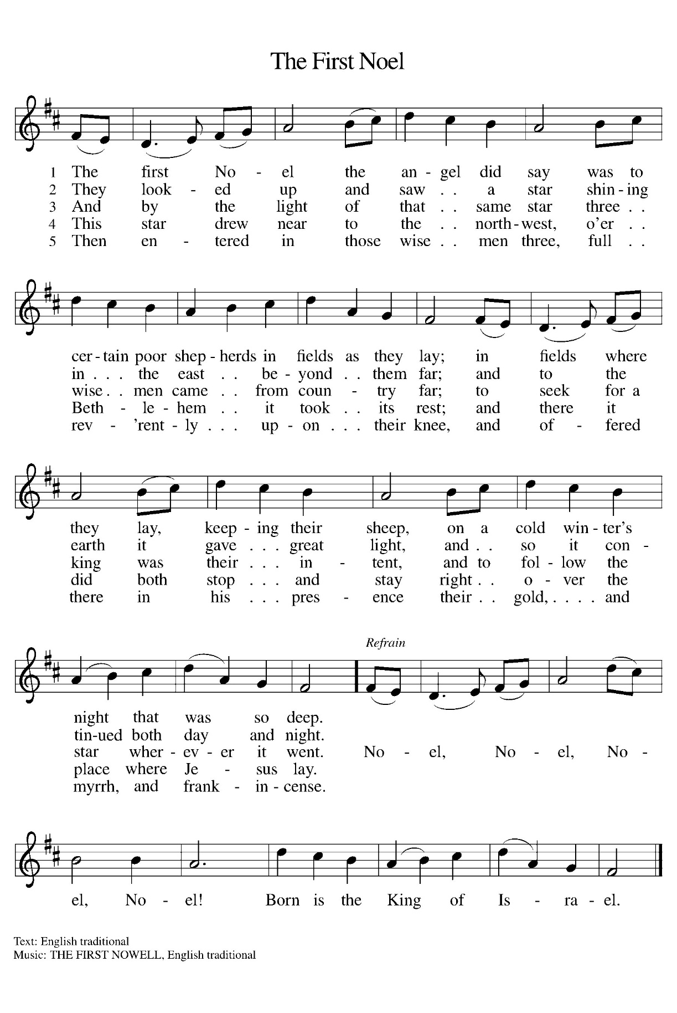

GREETING
The grace of our Lord Jesus Christ, the love of God,
and the communion of the Holy Spirit be with you all.
And also with you.

KYRIE

For jealousies that divide families and nations,
and for rivalries that create strife and warfare:

For idleness in witnessing to Jesus Christ,
and for squandering the gifts of love and grace:

SONG OF PRAISE

Prayer of the Day
God of all people, You called many by name, asking them to follow Jesus and obey. Call us by name, and help us to follow and obey. Amen

CHILDREN’S BIBLE STORY

FIRST READING Psalm 66:1-5
¹ Make a joyful noise to God, all the earth;
² sing the glory of his name;
give to him glorious praise.
³ Say to God, “How awesome are your deeds!
Because of your great power, your enemies cringe before you.
⁴ All the earth worships you;
they sing praises to you,
sing praises to your name.”
⁵ Come and see what God has done:
he is awesome in his deeds among mortals.

Acclamation
The assembly stands.

The Holy Gospel according to John the 1st chapter.
Glory to you, O Lord.

Gospel: John 1:35-51
³⁵ The next day John again was standing with two of his disciples, ³⁶ and as he watched Jesus walk by he exclaimed, “Look, here is the Lamb of God!” ³⁷ The two disciples heard him say this, and they followed Jesus. ³⁸ When Jesus turned and saw them following, he said to them, “What are you looking for?” They said to him, “Rabbi” (which translated means Teacher), “where are you staying?” ³⁹ He said to them, “Come and see.” They came and saw where he was staying, and they remained with him that day. It was about four o’clock in the afternoon. ⁴⁰ One of the two who heard John speak and followed him was Andrew, Simon Peter’s brother. ⁴¹ He first found his brother Simon and said to him, “We have found the Messiah” (which is translated Anointed). ⁴² He brought Simon to Jesus, who looked at him and said, “You are Simon son of John. You are to be called Cephas” (which is translated Peter).
⁴³ The next day Jesus decided to go to Galilee. He found Philip and said to him, “Follow me.” ⁴⁴ Now Philip was from Bethsaida, the city of Andrew and Peter. ⁴⁵ Philip found Nathanael and said to him, “We have found him about whom Moses in the Law and also the Prophets wrote, Jesus son of Joseph from Nazareth.” ⁴⁶ Nathanael said to him, “Can anything good come out of Nazareth?” Philip said to him, “Come and see.” ⁴⁷ When Jesus saw Nathanael coming toward him, he said of him, “Here is truly an Israelite in whom there is no deceit!” ⁴⁸ Nathanael asked him, “Where did you get to know me?” Jesus answered, “I saw you under the fig tree before Philip called you.” ⁴⁹ Nathanael replied, “Rabbi, you are the Son of God! You are the King of Israel!” ⁵⁰ Jesus answered, “Do you believe because I told you that I saw you under the fig tree? You will see greater things than these.” ⁵¹ And he said to him, “Very truly, I tell you, you will see heaven opened and the angels of God ascending and descending upon the Son of Man.”

The gospel of the Lord.
Praise to you, O Christ.

SERMON

HYMN OF THE DAY Lord, I Lift Your Name on High ELW 857

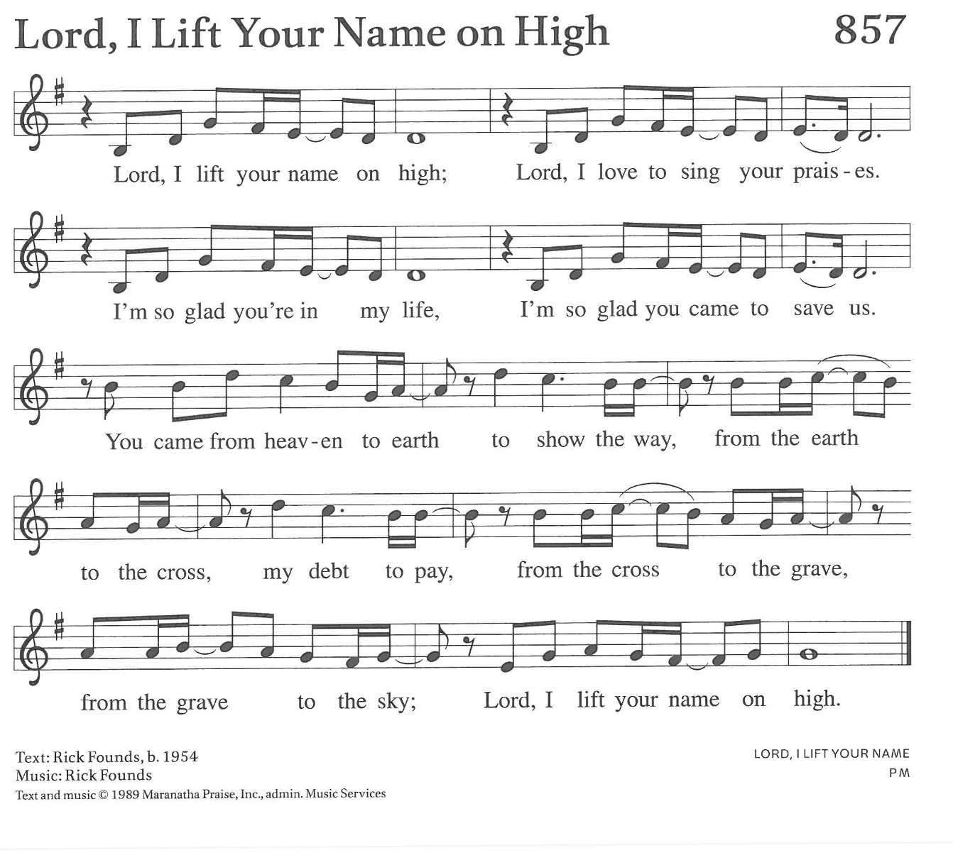The Nicene Creed
We believe in one God,
the Father, the Almighty,
maker of heaven and earth,
of all that is, seen and unseen.
We believe in one Lord, Jesus Christ,
the only Son of God,
eternally begotten of the Father,
God from God, Light from Light,
true God from true God, begotten, not made,
of one Being with the Father;
through him all things were made.

For us and for our salvation
he came down from heaven,
was incarnate of the Holy Spirit and the virgin Mary
and became truly human.
For our sake he was crucified under Pontius Pilate;
he suffered death and was buried.
On the third day he rose again
in accordance with the scriptures;
he ascended into heaven
and is seated at the right hand of the Father.
He will come again in glory to judge
the living and the dead,
and his kingdom will have no end.
We believe in the Holy Spirit, the Lord, the giver of life,
who proceeds from the Father and the Son,
who with the Father and the Son
is worshiped and glorified,
who has spoken through the prophets.
We believe in one holy catholic and apostolic church.
We acknowledge one baptism
for the forgiveness of sins.
We look for the resurrection of the dead,
and the life of the world to come. Amen.

PrayeRs of intercession
After each petition the congregation responds: God of grace, receive our prayer.
In our waiting and watching, we come to you in prayer, O God, trusting your promise to renew the church, the nations, and the whole creation.
Repeat To You All Hearts Are Open

Peace
The peace of the Lord be with you always.
And also with you.

Offering

Offertory Song

OFFERING PRAYER
God of glory,
great are your wonders among us
and many are the blessings you bestow.
Use us and these your gifts for the needs of the world,
that all the ends of the earth may rejoice in your saving grace,
through Christ our Savior.
Amen.

Great thanksgiving
The Lord be with you.
And also with you.
Lift up your hearts.
We lift them to the Lord.
Let us give thanks to the Lord our God.
It is right to give our thanks and praise.

the Lord’s prayer
Our Father, who art in heaven,
hallowed be thy name,
thy kingdom come,
thy will be done,
on earth as it is in heaven.
Give us this day our daily bread;
and forgive us our trespasses,
as we forgive those who trespass against us;
and lead us not into temptation,
but deliver us from evil.
For thine is the kingdom, and the power, and the glory,
forever and ever. Amen.

Invitation to Communion

Invite those communing at home

This is Christ’s table and Christ welcomes each and every single one of you.

  - Communion Hymn

Communion Distribution
All who desire the Lord’s Supper are invited to come forward to receive Holy Communion. Following the usher’s invitation, come forward along the side aisle and remain standing as you gather around the altar railing. When everyone has gathered at the railing, you may kneel or remain standing. Receive the wafer of bread in your hands. You may also request a gluten-free wafer. Then take a small cup from the tray: white grape juice is in the center and red wine is around the edge. Deposit your cup in the basket when you are finished and return to your seat down the center aisle. We invite children and those not receiving the bread and wine to come forward to receive a blessing at the altar railing.

SONG after communion
Sing verse 1 and 4

Prayer after Communion
Incarnate God, you are among us at this table.
May we treasure this gift and ponder in our hearts
the mystery of your presence.
Move us to discover the wonders of your love
in the everyday moments of our lives,
through Christ born in us.
Amen.


Blessing

Dismissal

Glory to God in the highest!
And peace to God’s people on earth!
Go in joy. Embody God’s redeeming grace.
Thanks be to God.

Each month our prayer list in the bulletins will begin again for those with an immediate prayer need. To have someone put back on the printed list, simply contact the church office. Please remember to have your loved one removed from the list when the urgency for prayer has passed.

Congratulations to Grace & Cody Lampkowski on the birth of their daughter, Allie Kay. Allie was born on December 28, 2025, weighed 7 lb. 13 oz and was 20 ¼” long at birth. Be sure to ask Luke about his baby sister!

New players are welcome and encouraged to join in the fun of dartball Games are played on Monday evenings at 7:30 at the area churches and are on break and will resume on January 05. Contact Paul Ness for more info @ 734-770-6389 and a schedule.

Weekly Adult Bible Study resumes on Tues., Jan. 06 at 9:30 AM. Pastor Aaron leads the study of the next Sunday’s reading. Bring a friend.

It's our turn to help with God Works Soup kitchen at St. John’s in Dundee on Wed., Jan 14. Youth & their families are helping - sign up in the narthex.

The nominating committee is still looking for members who are interested in sharing their gifts and talents to serve on church council. If you are interested in learning more about any of the remaining positions or would like to volunteer for one of them, please contact a member of the Nominating Committee, Tim Smith, Barb DeLand, Lynne Zabawa, Dave Lorenzo, Deena Salenbien, John Gerweck or Andy McCain. We are hoping to have candidates for all positions by the first full week of January. We are still in need of 1 President-elect, 1 trustee, and possibly 3 nominating committee members.

Your 2026 offering envelopes are available for pick up. Please, look at them and make sure that the number on the label matches the number on the envelopes in the box and that your name is correct. If you notice any problems or cannot find your envelopes contact the church office.


You may also direct deposit or scan to donate an offering:

Drop off your undecorated, live Christmas tree
in the picnic shelter to use in Journey to the Cross

Serving our congregation this morning:
Acolytes – Roman Jacks and Landry Jacks
Altar Guild – Mindy Stadler and Kim Cramer
Fellowship Hour – Jan Fisk and Roxie Boll w/donations from Diane Matthes
Liturgical Minister – Jen Hemry
Media – Kelsey Creguer
Organist – Ray Smith
Ushers –Tom Fruchey, Head User; Jan Fruchey, Julie Gimesky, Kim Kibat

Schedule: Today: Holy Communion – 9 AM
Fellowship Hour – 10 AM
“Un”-Decorate the Sanctuary
Monday: Dartball – PoP @ St John Dundee – 7:30 PM
Tuesday: Adult Bible Study – 9:30 AM
Alochol Anonymous – 7:00 PM
Wednesday: Mid-Week Worship – 7:00 PM
Thursday: Pickleball 6:00 PM

Coming Soon:
Jan 11 – Sunday School & Catechism Resume
Jan 14 – God Works Soup Kitchen
Jan 15 – Lunch & Learn @ Monroe Center for Healthy Aging w/Pastor Aaron
Jan 15 – JTTC Meeting – 7:00 PM
Jan. 18 – Grades 3-5 Prayer Milestone Class
Jan 18 – Youth Outing to Funagins
Jan 19 – Martin Luther King Day
Jan 25 – Annual Meeting & Potluck – 10 AM

Local Event…
Jan 16– Roast beef dinner @ E Ida Immanuel Lutheran Church, 6272 W Albain Rd. Monroe. Meal includes roast beef, mashed potatoes w/gravy, green beans or corn, applesauce or coleslaw, dinner roll, beverage & dessert. Adults $12; kids 5-10 $8; kids 4 & under free. Carry-out available! Proceeds benefit a different Monroe County charity organization each month










