December 07, 2025

Prelude & Announcements
Temple talk Tim Smith
Advent Candle Lighting
O Come, O Come, Emmanuel vv 1,6 ELW 257
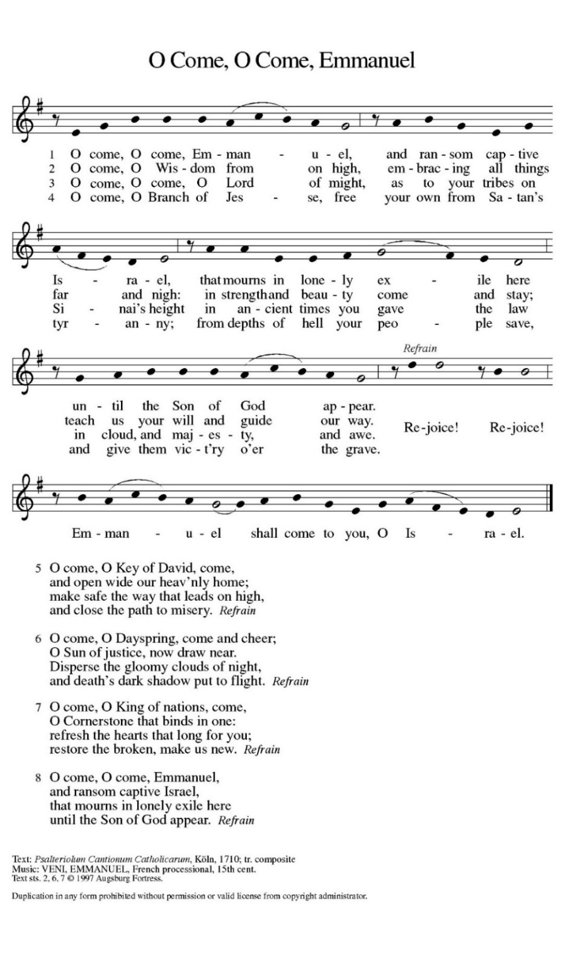

Gathering Song All Earth Is Hopeful vv. 1-3 ELW 266
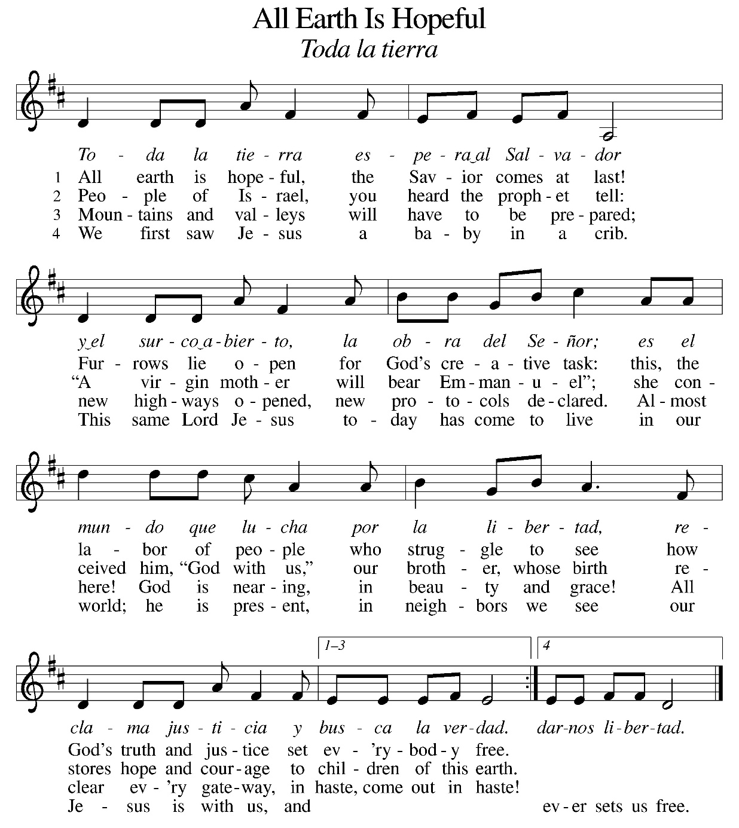

Greeting
The grace of our Lord Jesus Christ, the love of God,
and the communion of the Holy Spirit be with you all.
And also with you.

KYRIE

For jealousies that divide families and nations,
and for rivalries that create strife and warfare:

For idleness in witnessing to Jesus Christ,
and for squandering the gifts of love and grace:

Song of praise

Prayer of the Day
God of breath, you promised new life to your people in exile by breathing into a valley full of dry bones. Breathe new life into us, so that we might live passionately for you.
Amen

CHILDREN’S BIBLE STORY

First READING Ezekiel 37:1-14
¹ The hand of the Lord came upon me, and he brought me out by the spirit of the Lord and set me down in the middle of a valley; it was full of bones. ² He led me all around them; there were very many lying in the valley, and they were very dry. ³ He said to me, “Mortal, can these bones live?” I answered, “O Lord God, you know.” ⁴ Then he said to me, “Prophesy to these bones and say to them: O dry bones, hear the word of the Lord. ⁵ Thus says the Lord God to these bones: I will cause breath to enter you, and you shall live. ⁶ I will lay sinews on you and will cause flesh to come upon you and cover you with skin and put breath in you, and you shall live, and you shall know that I am the Lord.”
⁷ So I prophesied as I had been commanded, and as I prophesied, suddenly there was a noise, a rattling, and the bones came together, bone to its bone. ⁸ I looked, and there were sinews on them, and flesh had come upon them, and skin had covered them, but there was no breath in them. ⁹ Then he said to me, “Prophesy to the breath, prophesy, mortal, and say to the breath: Thus says the Lord God: Come from the four winds, O breath, and breathe upon these slain, that they may live.” ¹⁰ I prophesied as he commanded me, and the breath came into them, and they lived and stood on their feet, a vast multitude.
¹¹ Then he said to me, “Mortal, these bones are the whole house of Israel. They say, ‘Our bones are dried up, and our hope is lost; we are cut off completely.’ ¹² Therefore prophesy and say to them: Thus says the Lord God: I am going to open your graves and bring you up from your graves, O my people, and I will bring you back to the land of Israel. ¹³ And you shall know that I am the Lord when I open your graves and bring you up from your graves, O my people. ¹⁴ I will put my spirit within you, and you shall live, and I will place you on your own soil; then you shall know that I, the Lord, have spoken and will act, says the Lord.”

After the reading concludes:
Word of God, word of Life.
Thanks be to God.
The assembly stands to welcome the gospel.

Gospel Acclamation

The gospel is announced.
The holy gospel according to John the 11th chapter
Glory to you, O Lord.

GOSPEL John 11:25-26
25 Jesus said to her, “I am the resurrection and the life. Those who believe in me, even though they die, will live, 26 and everyone who lives and believes in me will never die. Do you believe this?

The gospel concludes:
The gospel of the Lord.
Praise to you, O Christ.

Sermon Pastor Aaron D. Werner

Hymn of the DAY Awake, O Sleeper, Rise from Death vv. 1,2,5 ELW452
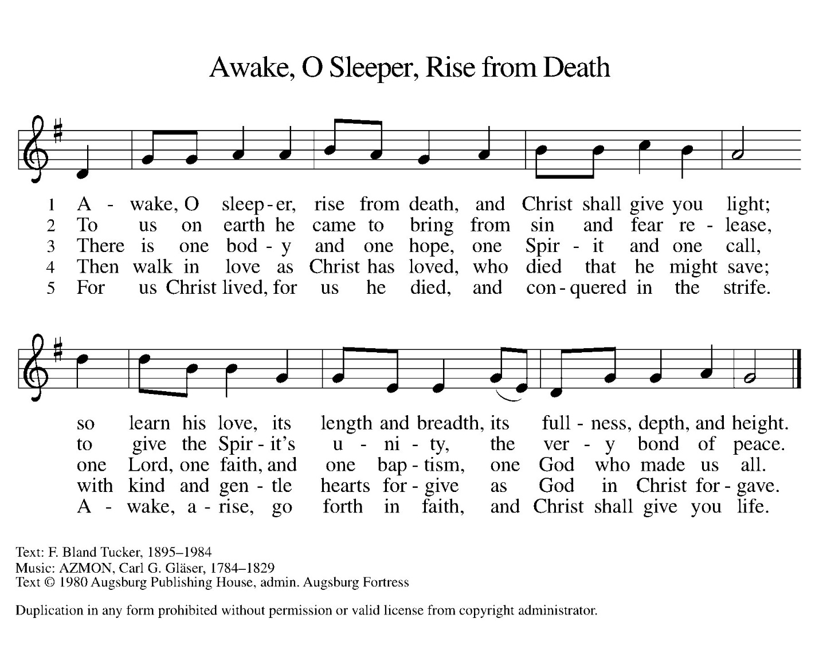

APOSTLES” Creed
I believe in God, the Father almighty,
creator of heaven and earth.

I believe in Jesus Christ, God’s only Son, our Lord,
who was conceived by the Holy Spirit,
born of the virgin Mary,
suffered under Pontius Pilate,
was crucified, died, and was buried;
he descended to the dead.
On the third day he rose again;
he ascended into heaven,
he is seated at the right hand of the Father,
and he will come to judge the living and the dead.

I believe in the Holy Spirit,
the holy catholic church,
the communion of saints,
the forgiveness of sins,
the resurrection of the body,
and the life everlasting. Amen.

PrayeRs of intercession
After each petition the congregation responds: God of grace, receive our prayer.

In our waiting and watching, we come to you in prayer, O God, trusting your promise to renew the church, the nations, and the whole creation.

(Prayers of intercession continue)

Peace
The peace of Christ be with you always.
And also with you.
The people may greet one another with a sign of Christ’s peace, and may say, “Peace be with you,” or similar words.
The assembly is seated.
offerinG

offering SONG
offering Prayer
Nourishing God,
you are water in the wilderness and streams in the desert.
Through this meal, satisfy our parched places,
that we may rejoice and be for the world
signs of your kingdom come.
Amen.

Great Thanksgiving
The Lord be with you.
And also with you.
Lift up your hearts.
We lift them to the Lord.
Let us give thanks to the Lord our God.
It is right to give our thanks and praise.

Lord’s PrayeR
Our Father, who art in heaven, hallowed be thy name,
thy kingdom come, thy will be done,
on earth as it is in heaven.
Give us this day our daily bread;
and forgive us our trespasses,
as we forgive those who trespass against us;
and lead us not into temptation,
but deliver us from evil.
For thine is the kingdom, and the power, and the glory,
forever and ever. Amen.

Invitation to Communion
This is Christ’s table and Christ welcomes each and every single one of you. Those of you communion at home, please join us.

  - Communion Hymn

Communion Distribution
All who desire the Lord’s Supper are invited to come forward to receive Holy Communion. Following the usher’s invitation, come forward along the side aisle and remain standing as you gather around the altar railing. When everyone has gathered at the railing, you may kneel or remain standing. Receive the wafer of bread in your hands. You may also request a gluten-free wafer. Then take a small cup from the tray: white grape juice is in the center and red wine is around the edge. Deposit your cup in the basket when you are finished and return to your seat down the center aisle. We invite children and those not receiving the bread and wine to come forward to receive a blessing at the altar railing.

Song After communion vv 1,4

PRAYER AFTER COMMUNION
God our host,
at this table you have fed us with joy and gladness.
Send us forth, eager to share the feast,
welcome the stranger,
and bear good fruit in the name of Jesus.
Amen.

Blessing
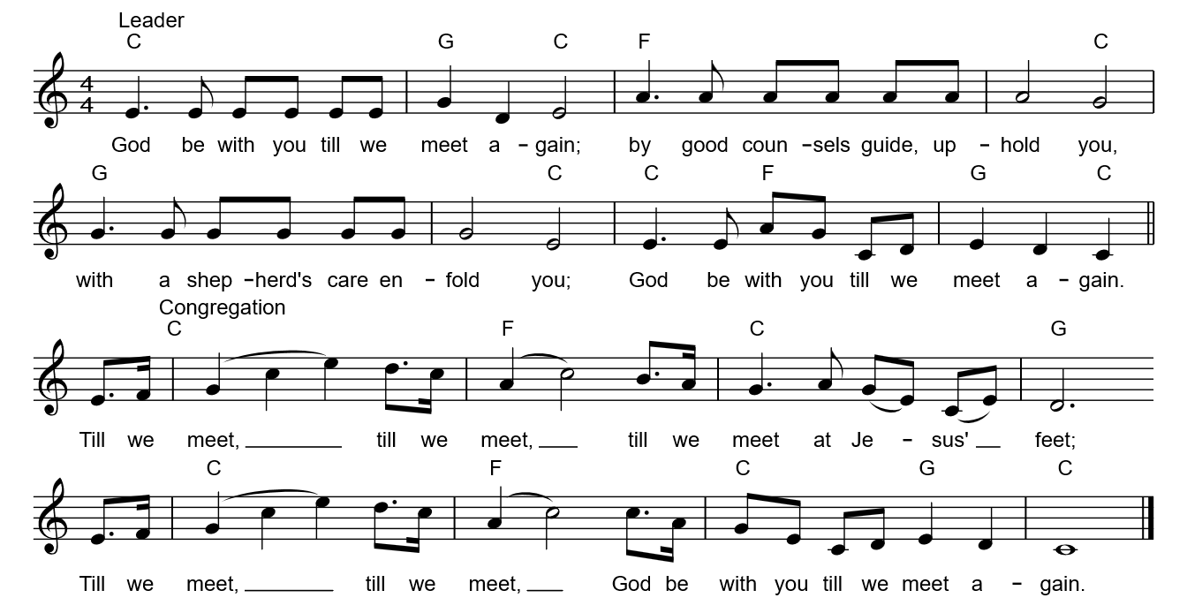

Dismissal
Go in peace. Keep awake. Thanks be to God.

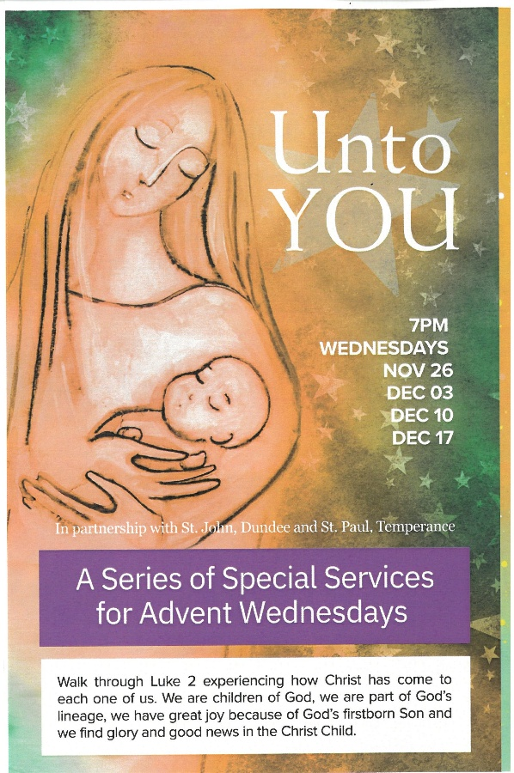
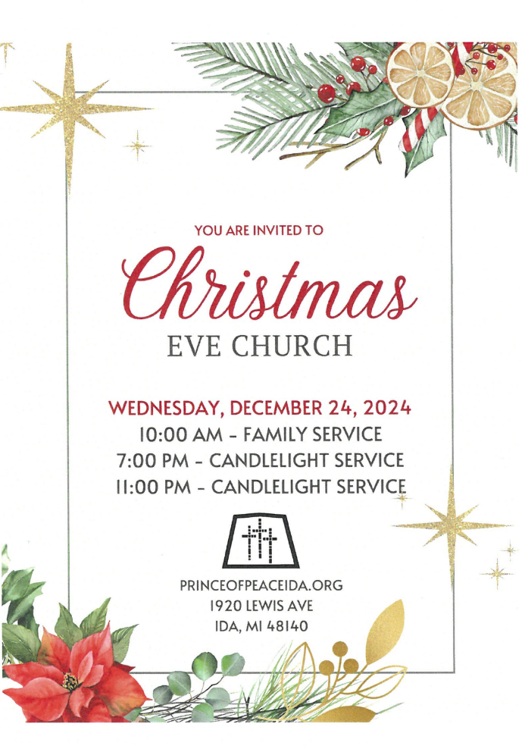

Please remember in prayer: Our Parishioners: especially JoAnn Capaul-Smallidge; Darlene Dull; Joy Fox; Diana Kutzke; Vicki Vagt; Friends and Relatives: Heather Alfred; family of Brad Beck; Mindy Bieber; Heather Blanchard; Elmer Bowman; Jenner Bowman; Angie Cole; Bill Cole; Michael Cook; Scott DeBruin; Tom DuPont; Glenda Edlebrock; Connie Eipperle; Nishi Ghai; Dave Gauding; Myles Gossiaux; Terry Heck; Brian Hoppert; Tim Jarvis; Janet Knight; Sara Nieswand; Fhonda Price; Pam Puhl; Cassie Roberts; Andy Scharer & Carly; Joseph Shock; Greg “Chopper” Smith; Sherry Watters; all those who serve in our military, struggling Veterans, and their families. Bless our River Raising Conference Partner St Paul Lutheran Church in Maybee, LLM Jim Puhl; and our Bishops Yehiel Curry and Donald Kreiss.

If you’d like to contribute cash for the purchase of fresh fruit, for the homebound baskets, or have any questions, please contact Anita Hanson 734-731-2490. The baskets will be delivered when we Christmas Carol on Dec. 14.

Please send one Christmas card for your entire Prince of Peace family. Your card will be displayed in the Narthex, with the others.

Our Christian sympathy is extended to the family and friends of William “Brad” Beck, Shawn Kreps brother, who passed away on November 24, 2025. His funeral service was last week.

Local Events…
Dec 14 – Old Time Christmas Carol Sing Along @ St. Paul Lutheran Church 7771 High St in Maybee @ 1 :30 PM. Spend a relaxing hour singing traditional carols of old featuring musicians from St. Paul’s on piano, organ and trombone! Refreshments follow. The event is free. Contact Sandra Lentner s.lentner@chartermi.net if you have any questions.

Dec. 19 – Roast beef dinner @ E Ida Immanuel Lutheran Church, 6272 W Albain Rd. Monroe. Meal includes roast beef, mashed potatoes w/gravy, green beans or corn, applesauce or coleslaw, dinner roll, beverage & dessert. Adults $12; kids 5-10 $8; kids 4 & under free. Carry-out available! Proceeds benefit a different Monroe County charity organization each month

Dec 19 – John Tyner Chorale presents its annual Festival of Lessons and Carols on Fri Dec 19 @ 7:30 PM. The performance will be held in IHM Motherhouse Chapel 610 W Elm Ave Monroe, MI 48162. It’s modeled after the Christmas Eve service that has taken place in Cambridge Cathedral in England since 1918. It includes scripture readings by various pastors and community leaders from the Monroe area with carols performed by the congregation and others by the John Tyner Choral. This style of service has been used widely around the world. The event is free and open to the public. A free will offering will be collected for the benefit of the performers and the IHM Chapel Concert Series.

Serving our congregation this morning:
Acolytes – Roman Jacks and Landry Jacks
Advent Candlelighter & Reader – Shawna Russell and Aleena
Altar Guild – Barb DeLand, Kelsey Creguer and Cheryl Stotz
Fellowship Hour – Aimee Prati w/donations from Tom & Jan Fruchey
Liturgical Minister – Kim Zietlow
Media – Brian DeLand
Organist – Ray Smith
Ushers – Andy Clark, Head Usher; Ann, Shane & Seth Clark

Schedule:
Sunday: Holy Communion - 9:00 AM
Fellowship Hour – 10:00 AM
SS Program Practice – 10:15 AM
Monday: IKC Christmas Program & Party – 6:00 PM
Dartball –PoP @ Trinity Riga – 7:30 PM
Tuesday: Alcohol Anonymous - 7:00 PM
Wednesday: Country Christmas Worship Service – 7:00 PM
Thursday: Blood Drive 11 AM – 5 PM
Pickleball – 6 PM
Friday: Youth Christmas Party, Service Project & Movie Night – 5:30 PM

Coming Soon
Sun Dec. 14 – Christmas Caroling to Homebound – 11 AM
Sun Dec. 21 – Sunday School Christmas Program – 9 AM
Wed Dec. 24 – Christmas Eve Services – 10 AM, 7 & 11 PM
Thurs Dec. 25 – Christmas Day – no services
Sun Dec. 28 – Lessons & Carols – 9 AM
Wed Dec 31 – New Year’s Eve – No Services


Support God’s Ministry at Prince of Peace
Give via our website: princeofpeaceida.org.
You may also direct deposit or scan to donate:

