December 24, 2025
PRELUDE
Special music 10 AM Sidney Roderick
7 PM Kelsey Creguer
11PM Sarah Prati Welcome & Announcements

O Come, O Come, Emmanuel ELW 257
O come, O come, Emmanuel, and ransom captive Israel,
that mourns in lonely exile here until the Son of God appear.
Refrain
Rejoice! Rejoice! Emmanuel
shall come to you, O Israel.

Lighting the Candles 10 Am Brent Jennings & Blake Gobrecht
7 PM McCain Family
11 PM Kim Cramer & Jayden
A candle is lit as each stanza is read.
God said, “Let there be light,” and there was light. And God saw that the light was good, and God separated the light from the darkness. (Genesis 1:3-4)
The people who walked in darkness have seen a great light; those who lived in a land of deep darkness—on them light has shined. (Isaiah 9:2)
In Christ was life, and the life was the light of all people. The light shines in the darkness, and the darkness did not overtake it. (John 1:4-5)
You are a chosen people, a royal priesthood, a holy nation, God’s own people, in order that you may proclaim the excellence of him who called you out of darkness into his marvelous light. (1 Peter 2:9)
Then the angel showed me the river of the water of life, bright as crystal, flowing from the throne of God and of the Lamb through the middle of the street of the city. And there will be no more night; they need no light of lamp or sun, for the Lord God will be their light. (Revelation 22:1-2, 5)

O Come, O Come, Emmanuel
O come, O Dayspring, come and cheer;
O Sun of justice, now draw near.
Disperse the gloomy clouds of night,
and death's dark shadow put to flight.
Refrain
Rejoice! Rejoice! Emmanuel
shall come to you, O Israel.

Proclamation of the Birth of Christ
The assembly stands and faces the entrance to the sanctuary.
The priest Zechariah, filled with the Holy Spirit prophesied, “Blessed be the Lord God of Israel, for he has looked favorably on his people and redeemed them. He has raised up a mighty savior for us in the house of his child David, as he spoke through the mouth of his holy prophets from of old:
The tender mercy of our God,
the dawn from on high will break upon us,
to shine upon those who sit in darkness
and in the shadow of death,
to guide our feet into the way of peace.”
(Luke 1:67-70, 78-79)
Now in our own times God’s word has been fulfilled.
Born this day in our own city, is our Savior, Immanuel,
God with us, God’s word made flesh.
Jesus, you are the bright Morning Star,
shine for all to see.
Jesus, may your radiant love guide us
through the darkness.
Jesus, by your Holy Spirit, sing through us
the song of your holy angels,
peace on earth, good will to all.
Amen.

Procession
The assembly turns to follow the Light of Christ as it enters the sanctuary, singing:

O Come, All Ye Faithful ELW 283
1 O come, all ye faithful, joyful and triumphant!
O come ye, O come ye to Bethlehem;
come and behold him, born the king of angels:
Refrain
O come, let us adore him,
O come, let us adore him,
O come, let us adore him,
Christ the Lord!

2 The highest, most holy, light of light eternal,
born of a virgin, a mortal he comes;
Son of the Father now in flesh appearing! Refrain

3 Sing, choirs of angels, sing in exultation,
sing, all ye citizens of heaven above!
Glory to God in the highest: Refrain

Prayer of the Day
The Lord be with you.
And also with you.
Let us pray. God, we celebrate with you the birth of your son, and together we sing with the angels, “Glory to God in the highest heaven, and on earth peace, goodwill among all people!”
Amen.

O Little Town of Bethlehem ELW 279
Children come forward to sit at the front of the sanctuary. The assembly is seated.
1 O little town of Bethlehem, how still we see thee lie!
Above thy deep and dreamless sleep the silent stars go by;
yet in thy dark streets shineth the everlasting light.
The hopes and fears of all the years are met in thee tonight.

Children’s Bible Story

O Little Town of Bethlehem ELW 279
Children return to their seats.
2 For Christ is born of Mary, and, gathered all above
while mortals sleep, the angels keep their watch of wond'ring love.
O morning stars, together proclaim the holy birth,
and praises sing to God the king, and peace to all the earth!

Luke 2:1-7
In those days a decree went out from Emperor Augustus that all the world should be registered. This was the first registration and was taken while Quirinius was governor of Syria. All went to their own towns to be registered. Joseph also went from the town of Nazareth in Galilee to Judea, to the city of David called Bethlehem, because he was descended from the house and family of David. He went to be registered with Mary, to whom he was engaged and who was expecting a child. While they were there, the time came for her to deliver her child. And she gave birth to her firstborn son and wrapped him in bands of cloth, and laid him in a manger, because there was no place for them in the inn.

Away in a Manger ELW 277
1 Away in a manger, no crib for his bed,
the little Lord Jesus laid down his sweet head;
the stars in the bright sky looked down where he lay,
the little Lord Jesus asleep on the hay.
2 The cattle are lowing; the baby awakes,
but little Lord Jesus, no crying he makes.
I love you, Lord Jesus; look down from the sky
and stay by my cradle till morning is nigh.

Luke 2:8-14
In that region there were shepherds living in the fields, keeping watch over their flock by night. Then an angel of the Lord stood before them, and the glory of the Lord shone around them, and they were terrified. But the angel said to them, “Do not be afraid; for see—I am bringing you good news of great joy for all the people: to you is born this day in the city of David a Savior, who is the Messiah, the Lord. This will be a sign for you: you will find a child wrapped in bands of cloth and lying in a manger.” And suddenly there was with the angel a multitude of the heavenly host, praising God and saying, “Glory to God in the highest heaven, and peace on earth, goodwill to all!”

Hark! The Herald Angels Sing ELW 270
1 Hark! The herald angels sing, "Glory to the newborn king;
peace on earth, and mercy mild, God and sinners reconciled."
Joyful, all you nations, rise; join the triumph of the skies; with angelic hosts proclaim, "Christ is born in Bethlehem!"
Refrain
Hark! The herald angels sing,
"Glory to the newborn king!"
3 Hail the heav'n-born Prince of peace!
Hail the Sun of righteousness!
Light and life to all he brings, ris'n with healing in his wings.
Mild he lays his glory by, born that we no more may die,
born to raise each child of earth, born to give us second birth. Refrain

Luke 2:15-20
15When the angels had left them and gone into heaven, the shepherds said to one another, “Let us go now to Bethlehem and see this thing that has taken place, which the Lord has made known to us.” 16So they went with haste and found Mary and Joseph, and the child lying in the manger. 17When they saw this, they made known what had been told them about this child; 18and all who heard it were amazed at what the shepherds told them. 19But Mary treasured all these words and pondered them in her heart. 20The shepherds returned, glorifying and praising God for all they had heard and seen, as it had been told them.

What Child Is This ELW 296
1 What child is this, who, laid to rest, on Mary's lap is sleeping?
Whom angels greet with anthems sweet
while shepherds watch are keeping?
This, this is Christ the king,
whom shepherds guard and angels sing;
haste, haste to bring him laud, the babe, the son of Mary!

2 Why lies he in such mean estate where ox and ass are feeding?
Good Christian, fear; for sinners here
the silent Word is pleading.
Nails, spear shall pierce him through,
the cross be borne for me, for you;
hail, hail the Word made flesh, the babe, the son of Mary!

Sermon

O Little Town of Bethlehem ELW 279
3 How silently, how silently the wondrous gift is giv'n!
So God imparts to human hearts the blessings of his heav'n.
No ear may hear his coming; but, in this world of sin,
where meek souls will receive him, still the dear Christ enters in.
4 O holy child of Bethlehem, descend to us, we pray;
cast out our sin, and enter in, be born in us today.
We hear the Christmas angels the great glad tidings tell;
oh, come to us, abide with us, our Lord Immanuel!

The Nicene Creed
We believe in one God,
the Father, the Almighty,
maker of heaven and earth,
of all that is, seen and unseen.
We believe in one Lord, Jesus Christ,
the only Son of God,
eternally begotten of the Father,
God from God, Light from Light,
true God from true God, begotten, not made,
of one Being with the Father;
through him all things were made.

For us and for our salvation
he came down from heaven,
was incarnate of the Holy Spirit and the virgin Mary
and became truly human.
For our sake he was crucified under Pontius Pilate;
he suffered death and was buried.
On the third day he rose again
in accordance with the scriptures;
he ascended into heaven
and is seated at the right hand of the Father.
He will come again in glory to judge
the living and the dead,
and his kingdom will have no end.
We believe in the Holy Spirit, the Lord, the giver of life,
who proceeds from the Father and the Son,
who with the Father and the Son
is worshiped and glorified,
who has spoken through the prophets.
We believe in one holy catholic and apostolic church.
We acknowledge one baptism
for the forgiveness of sins.
We look for the resurrection of the dead,
and the life of the world to come. Amen.

Prayers of the People
After each petition the congregation responds: Merciful God, receive our prayer.

Peace
The peace of Christ be with you always.
And also with you.
The assembly greets one another with a sign of peace.

Offering
The assembly is seated as an offering is gathered for God’s mission in this church, including the care of those in need.

SPECIAL MUSIC 10 AM Grace Lampkowski 7 PM Kyle Gautz

Offering Prayer
God of glory,
great are your wonders among us
and many are the blessings you bestow.
Use us and these your gifts for the needs of the world,
that all the ends of the earth may rejoice in your saving grace,
through Christ our Savior. Amen.
HOLY COMMUNION

SPECIAL MUSIC 7 pm Elaine Bodi and Jan Fisk 7 PM Jessica Dusa
THE GREAT THANKSGIVING
The Lord be with you.
And also with you.
Lift up your hearts.
We lift them to the Lord.
Let us give thanks to the Lord our God.
It is right to give our thanks and praise.

WORDS OF INSTITUTION

The Lord’s Prayer
Our Father, who art in heaven,
hallowed be thy name, thy kingdom come,
thy will be done, on earth as it is in heaven.
Give us this day our daily bread;
and forgive us our trespasses,
as we forgive those who trespass against us;
and lead us not into temptation,
but deliver us from evil.
For thine is the kingdom, and the power, and the glory,
forever and ever. Amen.

Invitation to the Lord’s Supper
This is Christ’s table and Christ welcomes each and every single one of you. The assembly is seated.

Angels We Have Heard on High ELW 289
1 Angels we have heard on high, sweetly singing o'er the plains,
and the mountains in reply, echoing their joyous strains.
Refrain
Gloria in excelsis Deo; gloria in excelsis Deo.
3 Come to Bethlehem and see him whose birth the angels sing;
come, adore on bended knee Christ the Lord, the newborn king.

Special Music 10 AM Elaine Bodi and Jan Fisk
7 PM Kyle Gautz

Prayer After Communion
Incarnate God, you are among us at this table.
May we treasure this gift and ponder in our hearts
the mystery of your presence.
Move us to discover the wonders of your love in the everyday moments of our lives, through Christ born in us. Amen.

Candle Lighting (7pm & 11 PM)
The sanctuary is darkened. Votive candles are lit and the light is passed. Please keep lit candles vertical and tip unlit candles into the flame.

SPECIAL MUSIC 7 PM Jessica Dusa

Silent Night, Holy Night ELW 281 7 & 11 PM
1 Silent night, holy night! All is calm, all is bright
round yon virgin mother and child.
Holy Infant, so tender and mild,
sleep in heavenly peace, sleep in heavenly peace.

2 Silent night, holy night! Shepherds quake at the sight;
glories stream from heaven afar,
heav'nly hosts sing, alleluia!
Christ, the Savior, is born! Christ, the Savior, is born!

3 Silent night, holy night! Son of God, love's pure light
radiant beams from your holy face,
with the dawn of redeeming grace,
Jesus, Lord, at your birth, Jesus, Lord, at your birth.

Benediction
May the light of Christ, born this day, bring you
out of chaos into peace,
out of sadness into joy,
out of death and darkness and into everlasting + life.
Amen.

Joy to the World ELW 267
1 Joy to the world, the Lord is come!
Let earth receive her king;
let ev'ry heart prepare him room
and heav'n and nature sing, and heav'n and nature sing,
and heav'n, and heav'n and nature sing.

2 Joy to the earth, the Savior reigns!
Let all their songs employ,
while fields and floods, rocks, hills, and plains
repeat the sounding joy, repeat the sounding joy,
repeat, repeat the sounding joy.

3 No more let sin and sorrow grow
nor thorns infest the ground;
he comes to make his blessings flow
far as the curse is found, far as the curse is found,
far as, far as the curse is found.

4 He rules the world with truth and grace
and makes the nations prove
the glories of his righteousness
and wonders of his love, and wonders of his love,
and wonders, wonders of his love.

Dismissal
Glory to God in the highest!
And peace to God’s people on earth!
Go in joy. Love your neighbor.
Thanks be to God.

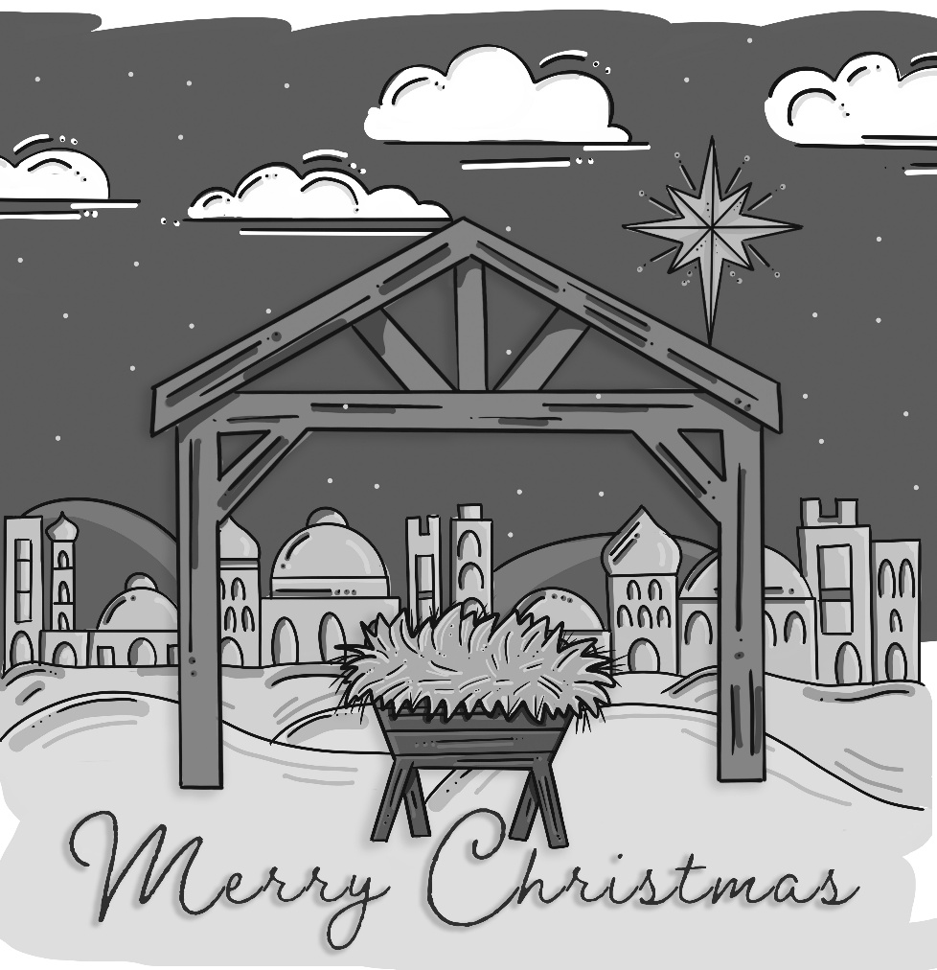

New players are welcome and encouraged to join in the fun of dartball Games are played on Monday evenings at 7:30 at the area churches and are on break and will resume on January 05. Contact Paul Ness for more info @ 734-770-6389 and a schedule.

Weekly Adult Bible Study resumes on Tues., Jan. 06 at 9:30 AM. Pastor Aaron leads the study of the next Sunday’s reading. Bring a friend.

It's our turn to help with God Works Soup kitchen at St. John’s in Dundee on Wed., January 14. Our youth and their families are helping. Please sign up in the narthex.

The new issues of Word in Season are located on the board near the coatroom and are free of charge. Large print editions are also available.

It’s that time of year again when the nominating committee is starting the process of looking for candidates that would be willing to run for a position on the church council. It’s an exciting time at Prince of Peace, and we are looking for members that share that excitement and want to help our church continue to carry this forward. If you are interested in learning more about any of the available positions or would like to volunteer for one of them, please contact a member of the Nominating Committee, Tim Smith, Barb DeLand, Lynne Zabawa, Dave Lorenzo, Deena Salenbien, John Gerweck or Andy McCain. We are hoping to have candidates for all positions by the first full week of January.

Our Christian sympathy is extended to the family and friends of JoAnn-Capaul Smallidge, who passed away on December 22. Funeral arrangements are pending.

Your 2026 offering envelopes are available for pick up. Please, look at them and make sure that the number on the label matches the number on the envelopes in the box and that your name is correct. If you notice any problems or cannot find your envelopes contact the church office.

You may also direct deposit or scan to donate an offering:

Serving our congregation this morning:
Acolytes – 10:00 AM – Brent Jennings and Blake Gobrecht
7:00 PM – Zoey McCain
Altar Guild – Barb DeLand, Kelsey Creguer, Cheryl Stotz
Wreath Candlelighters – 10:00 AM – Brent Jennings and Blake Gobrecht
7:00 PM – McCain Family
11:00 PM – Kim Cramer & Jayden
Lay Reader – 11:00 PM – Kim Cramer
Liturgical Ministers – 10:00 AM – Chris Knight; 7:00 PM – Tim Smith; 11:00 PM - Jennifer Hemry
Media – Kelsey Creguer
Organist – Ray Smith
Special Music – 10:00 AM – Grace Lampkowski, vocalist O Holy Night; Sidney Roderick, trumpet, Angels We Have Heard on High
7:00 PM – Elaine Bodi and Jan Fisk, vocalist “A Hallelujah Christmas" Kelsey Creguer, saxophone, It Came Upon a Midnight Clear and In the Bleak Midwinter; Jessica Dusa, flute Ava Maria and Silent Night; Kyle Gautz, violin
11:00 PM – Sarah Prati, piano
Ushers – 10:00 AM – Roxie Boll, Dave Fritz
7:00 PM – Jim DuRocher, Head Usher; Cindy DuRocher, Gary Miller, Nathan Miller
11:00 PM - Aimee Prati, Head Usher; Steven, Jacob, Eliana and Sarah Prati

Schedule: Today: Holy Communion - 10:00 AM; 7:00 & 11:00 PM
Thursday: Christmas Day No Service Tonight
No Pickleball
Saturday: Take Down candelabra – 9:00 AM

Drop off your undecorated, live Christmas tree
in the picnic shelter to use in Journey to the Cross

Coming Soon:
Dec 28 – Lessons & Carols Service 9 AM
Dec 31 – New Year’s Eve – No Service Tonight
Jan 01 – New Year’s Day – No Pickleball Tonight
Jan 04 – “Un”-Decorate the Sanctuary
Jan 06 – Adult Bible Study Begins – 9:30 AM
Jan 11 – Sunday School & Catechism Resume
Jan 14 – God Works Soup Kitchen
Jan 15 – JTTC Meeting – 7:00 PM
Jan. 18 – Grades 3-5 Prayer Milestone Class
Jan 18 – Youth Outing to Funagins


We wish to thank everyone for loaning us your poinsettias this evening. When you pick up your poinsettia(s), you may take one of the plastic sleeves located in the coat room. There is a list posted on the flower chart bulletin board outside Pastor’s office of which poinsettia(s) belong to you.

In Honor of:
…Christ’s birth from Leonard & Joy Fox

…Our church Family by Brian & Barb DeLand

…Chaplains by the Werner Family

…This Prince of Peace Family by Betty Nickel

In Memory of:

…Larry Kreps, III by Larry & Shawn Kreps

…Loved ones by Ron & Lynne Zabawa

… Larry Nickel by Betty Nickel

…Loved ones by Brian & Barb DeLand

…Chuckie Boll by Bink & Roxie Boll

…Loved ones by Eugene & Barb Ott

…Mr. & Mrs. Wm. Cairns by Cheryl Stotz

… Our parents by Paul & Jeannine Marks

… Tom Opfermann, Judy Wadysz, Roger Heiden, Steve Dull, Joanna Schlageter, Clare Tremlin, Marlene Howe, Samuel Longnecker, Cheryl Woelmer, Brian Bogedain, Herman Halter, Sue Albring, Don Stadler, Sid Gilbert

