November 30, 2025

Prelude & Announcements

Advent Candle Lighting
O Come, O Come, Emmanuel vv 1,4 ELW 257

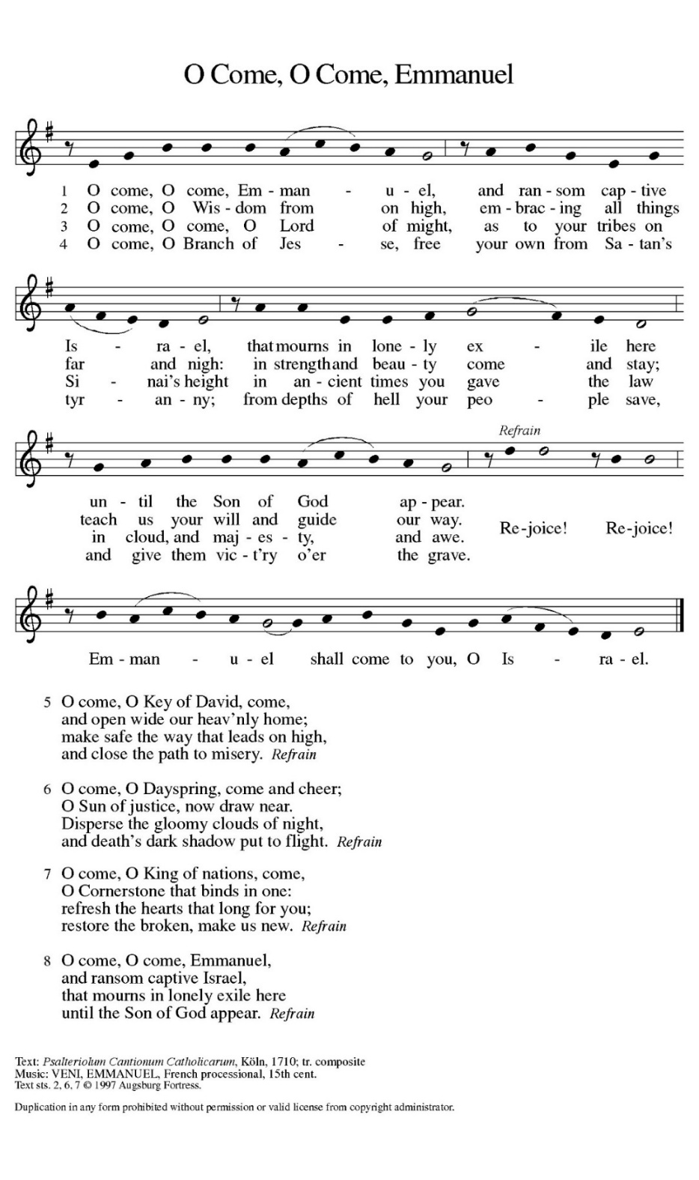

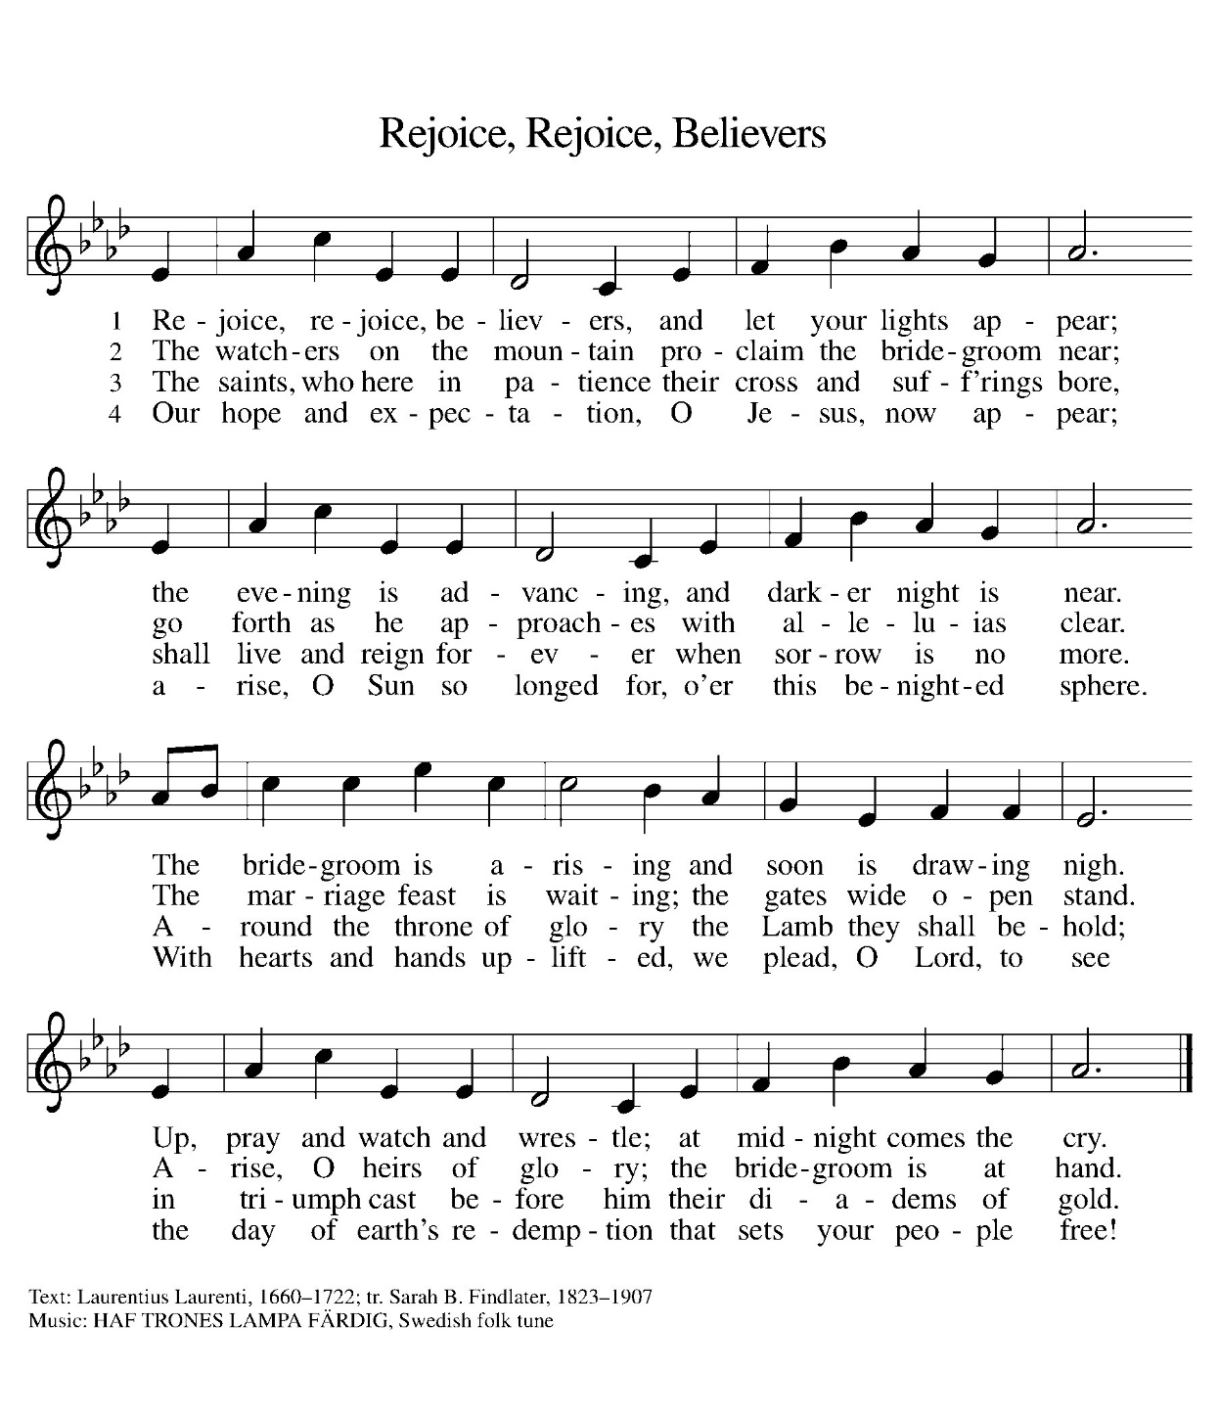
Gathering Song Rejoice, Rejoice Believers vv 1,2,4 ELW 244
Greeting
The grace of our Lord Jesus Christ, the love of God,
and the communion of the Holy Spirit be with you all.
And also with you.

KYRIE

For jealousies that divide families and nations,
and for rivalries that create strife and warfare:

For idleness in witnessing to Jesus Christ,
and for squandering the gifts of love and grace:

Song of praise

Prayer of the Day
God of fiery flames, Even the most raging fire could not destroy your servants when they called upon you in faith. Give us faith to withstand anything that rages to deter us from following you.
Amen

CHILDREN’S BIBLE STORY

First READING Daniel 3:1, [2-7] 8-30
¹ King Nebuchadnezzar made a golden statue whose height was sixty cubits and whose width was six cubits; he set it up on the plain of Dura in the province of Babylon.

[ ² Then King Nebuchadnezzar sent for the satraps, the prefects, and the governors, the counselors, the treasurers, the justices, the magistrates, and all the officials of the provinces to assemble and come to the dedication of the statue that King Nebuchadnezzar had set up. ³ So the satraps, the prefects, and the governors, the counselors, the treasurers, the justices, the magistrates, and all the officials of the provinces assembled for the dedication of the statue that King Nebuchadnezzar had set up. When they were standing before the statue that Nebuchadnezzar had set up, ⁴ the herald proclaimed aloud, “You are commanded, O peoples, nations, and languages, ⁵ that when you hear the sound of the horn, pipe, lyre, trigon, harp, drum, and entire musical ensemble, you are to fall down and worship the golden statue that King Nebuchadnezzar has set up. ⁶ Whoever does not fall down and worship shall immediately be thrown into a furnace of blazing fire.” ⁷ Therefore, as soon as all the peoples heard the sound of the horn, pipe, lyre, trigon, harp, drum, and entire musical ensemble, all the peoples, nations, and languages fell down and worshiped the golden statue that King Nebuchadnezzar had set up.]
⁸ Accordingly, at this time certain Chaldeans came forward and denounced the Jews. ⁹ They said to King Nebuchadnezzar, “O king, live forever! ¹⁰ You, O king, have made a decree, that everyone who hears the sound of the horn, pipe, lyre, trigon, harp, drum, and entire musical ensemble, shall fall down and worship the golden statue, ¹¹ and whoever does not fall down and worship shall be thrown into a furnace of blazing fire. ¹² There are certain Jews whom you have appointed over the affairs of the province of Babylon: Shadrach, Meshach, and Abednego. These men pay no heed to you, O king. They do not serve your gods, and they do not worship the golden statue that you have set up.”
¹³ Then Nebuchadnezzar in furious rage commanded that Shadrach, Meshach, and Abednego be brought in, so they brought those men before the king. ¹⁴ Nebuchadnezzar said to them, “Is it true, O Shadrach, Meshach, and Abednego, that you do not serve my gods and you do not worship the golden statue that I have set up? ¹⁵ Now if you are ready, when you hear the sound of the horn, pipe, lyre, trigon, harp, drum, and entire musical ensemble, you should fall down and worship the statue that I have made. But if you do not worship, you shall immediately be thrown into a furnace of blazing fire, and who is the god who will deliver you out of my hands?”
¹⁶ Shadrach, Meshach, and Abednego answered the king, “O Nebuchadnezzar, we have no need to present a defense to you in this matter. ¹⁷ If our God whom we serve is able to deliver us from the furnace of blazing fire and out of your hand, O king, let him deliver us. ¹⁸ But if not, be it known to you, O king, that we will not serve your gods and we will not worship the golden statue that you have set up.”
¹⁹ Then Nebuchadnezzar was so filled with rage against Shadrach, Meshach, and Abednego that his face was distorted. He ordered the furnace heated up seven times more than was customary ²⁰ and ordered some of the strongest guards in his army to bind Shadrach, Meshach, and Abednego and to throw them into the furnace of blazing fire. ²¹ So the men were bound, still wearing their tunics, their trousers, their hats, and their other garments, and they were thrown into the furnace of blazing fire. ²² Because the king’s command was urgent and the furnace was so overheated, the raging flames killed the men who lifted Shadrach, Meshach, and Abednego. ²³ But the three men, Shadrach, Meshach, and Abednego, fell down, bound, into the furnace of blazing fire.
²⁴ Then King Nebuchadnezzar was astonished and rose up quickly. He said to his counselors, “Was it not three men that we threw bound into the fire?” They answered the king, “True, O king.” ²⁵ He replied, “But I see four men unbound, walking in the middle of the fire, and they are not hurt, and the fourth has the appearance of a god.” ²⁶ Nebuchadnezzar then approached the door of the furnace of blazing fire and said, “Shadrach, Meshach, and Abednego, servants of the Most High God, come out! Come here!” So Shadrach, Meshach, and Abednego came out from the fire. ²⁷ And the satraps, the prefects, the governors, and the king’s counselors gathered together and saw that the fire had not had any power over the bodies of those men; the hair of their heads was not singed, their tunics were not scorched, and not even the smell of fire came from them. ²⁸ Nebuchadnezzar said, “Blessed be the God of Shadrach, Meshach, and Abednego, who has sent his angel and delivered his servants who trusted in him. They disobeyed the king’s command and yielded up their bodies rather than serve and worship any god except their own God. ²⁹ Therefore I make a decree: Any people, nation, or language that utters blasphemy against the God of Shadrach, Meshach, and Abednego shall be torn limb from limb and their houses laid in ruins, for there is no other god who is able to deliver in this way.” ³⁰ Then the king promoted Shadrach, Meshach, and Abednego in the province of Babylon.

After the reading concludes:
Word of God, word of Life.
Thanks be to God.
The assembly stands to welcome the gospel.

Gospel Acclamation

The gospel is announced.
The holy gospel according to John the 18th chapter
Glory to you, O Lord.

GOSPEL John 18:36-37
³⁶ Jesus answered, “My kingdom does not belong to this world. If my kingdom belonged to this world, my followers would be fighting to keep me from being handed over to the Jews. But as it is, my kingdom is not from here.” ³⁷ Pilate asked him, “So you are a king?” Jesus answered, “You say that I am a king. For this I was born, and for this I came into the world, to testify to the truth. Everyone who belongs to the truth listens to my voice.”

The gospel concludes:
The gospel of the Lord.
Praise to you, O Christ.

Sermon Pastor Aaron D. Werner

Hymn of the DAY Light One Candle to Watch for Messiah ELW 240

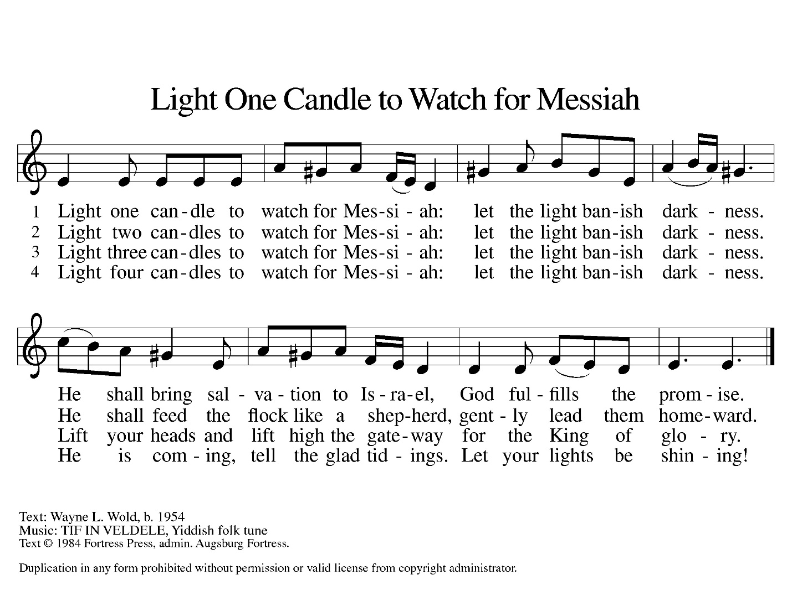

PrayeRs of intercession
After each petition the congregation responds: God of grace, receive our prayer.

In our waiting and watching, we come to you in prayer, O God, trusting your promise to renew the church, the nations, and the whole creation.

(Prayers of intercession continue)

Peace
The peace of Christ be with you always.
And also with you.
The people may greet one another with a sign of Christ’s peace, and may say, “Peace be with you,” or similar words.
The assembly is seated.
offerinG

offering SONG
offering Prayer
Nourishing God,
you are water in the wilderness and streams in the desert.
Through this meal, satisfy our parched places,
that we may rejoice and be for the world
signs of your kingdom come.
Amen.

Great Thanksgiving
The Lord be with you.
And also with you.
Lift up your hearts.
We lift them to the Lord.
Let us give thanks to the Lord our God.
It is right to give our thanks and praise.

Lord’s PrayeR
Our Father, who art in heaven, hallowed be thy name,
thy kingdom come, thy will be done,
on earth as it is in heaven.
Give us this day our daily bread;
and forgive us our trespasses,
as we forgive those who trespass against us;
and lead us not into temptation,
but deliver us from evil.
For thine is the kingdom, and the power, and the glory,
forever and ever. Amen.

Invitation to Communion
This is Christ’s table and Christ welcomes each and every single one of you. Those of you communion at home, please join us.

  - Communion Hymn
Communion Distribution
All who desire the Lord’s Supper are invited to come forward to receive Holy Communion. Following the usher’s invitation, come forward along the side aisle and remain standing as you gather around the altar railing. When everyone has gathered at the railing, you may kneel or remain standing. Receive the wafer of bread in your hands. You may also request a gluten-free wafer. Then take a small cup from the tray: white grape juice is in the center and red wine is around the edge. Deposit your cup in the basket when you are finished and return to your seat down the center aisle. We invite children and those not receiving the bread and wine to come forward to receive a blessing at the altar railing.

special music Elaine Bodi

Song After communion vv 1,4

PRAYER AFTER COMMUNION
God our host,
at this table you have fed us with joy and gladness.
Send us forth, eager to share the feast,
welcome the stranger,
and bear good fruit in the name of Jesus.
Amen.

Blessing
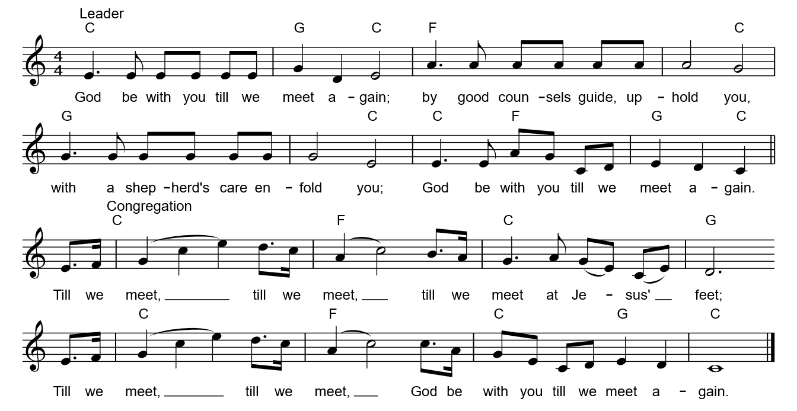

Dismissal
Go in peace. Keep awake. Thanks be to God.

SPECIAL WELCA MEETING: We know this is short notice, but we will be holding a special WELCA meeting today Sun, Nov 30th at 10 AM in the High School Room to discuss the cost of blinds previously approved at the November WELCA meeting. This meeting will only take a few minutes. All Women of the church are encouraged to attend. Any questions please contact Kim Cramer.

Someone is needed to lead the Advent reading and light the advent candle next Sunday, December 07. Traditionally, a parent, Godparent, or grandparent, etc and child(ren) sign up. See the sheet in the narthex to sign up. The reading is available, contact Kim Kibat in the church office.

Helpers & donations are needed for the WELCA lunch sold during the Christmas in Ida Craft Show in our Community Center on Dec 5. See the poster in the narthex and sign-up to prep food, donate items, etc.

Baked goodies and treats are needed for the WELCA Bake Sale table at Christmas in Ida on Dec 05. Bring your items on Fri Dec 04 or to the bake sale table on Dec 05. Please place a suggested price on your items. If you have any questions contact Roxie Boll, 734-497-3054.

The collection of small gifts and goodies for our homebound members continues through Sun., Dec. 7th. You may put them in the basket on the counter in the church office. If you’d like to contribute cash for the purchase of fresh fruit, or have any questions, please contact Anita Hanson 734-731-2490. The baskets will be delivered when we Christmas Carol on Dec. 14.

Please send one Christmas card for your entire Prince of Peace family. Your card will be displayed in the Narthex, with the others

It’s that time of year again when the nominating committee is starting the process of looking for candidates that would be willing to run for a position on the church council. It’s an exciting time at Prince of Peace, and we are looking for members that share that excitement and want to help our church continue to carry this forward. If you are interested in learning more about any of the available positions or would like to volunteer for one of them, please contact a member of the Nominating Committee, Tim Smith, Barb DeLand, Lynne Zabawa, Dave Lorenzo, Deena Salenbien, John Gerweck or Andy McCain.


Support God’s Ministry at Prince of Peace
Give via our website: princeofpeaceida.org.
You may also direct deposit or scan to donate:



Serving our congregation this morning:
Acolytes – Eva Lynn and Grace Dusa
Altar Guild – Laurie Sherman and Mindy Stadler
Fellowship Hour – Kim Zietlow
Liturgical Minister – Kristi Johnson
Media – Kelsey Creguer
Organist – Ray Smith
Special Music – Elaine Bodi
Ushers – Drew Lynn, Head Usher; the Lynn Family and Roxie Boll

Schedule:
Sunday: Holy Communion - 9:00 AM
WELCA Meeting – 10:00 AM
Fellowship Hour – 10:00 AM
SS Program Practice – 10:15 AM
Monday: Dartball – Immanuel N. Blissfield @ PoP – 7:30 PM
Tuesday: Advent by Candlelight – 6:30 PM
Alcohol Anonymous - 7:00 PM
Wednesday: Advent Worship Service – 7:00 PM
Thursday: Siberian Solstice Concert in CC – 7:00 PM
No Pickleball
Friday: WELCA Prep food for Craft show kitchen – 9:00 AM
Boy Choir of Ann Arbor in Sanctuary – 7:00 PM
Saturday: WELCA Bake Sale & Refreshments

Coming Soon
Mon Dec. 08 – Ida Kids Center Christmas Concert/Party – 6 PM
Wed Dec. 10 – Country Christmas service & Sing a Long 7 PM
Thurs Dec. 11 – Blood Drive
Fri Dec. 12 – Youth Movie Night and Service Project – 5:30-8:30 PM
Sun Dec. 14 – Christmas Caroling to Homebound – 11 AM
Sun Dec. 21 – Sunday School Christmas Program – 9 AM
Wed Dec. 24 – Christmas Eve Services – 10 AM, 7 & 11 PM
Thurs Dec. 25 – Christmas Day – no services
Sun Dec. 28 – Lessons & Carols – 9 AM

